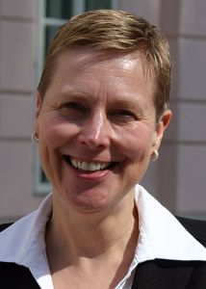 | Judith Paice, RN, PhD, FAAN is currently the Director of the Cancer Pain Program in the Division of Hematology-Oncology and a Research Professor of Medicine, Northwestern University; Feinberg School of Medicine. She is also a full member of the Robert H. Lurie Comprehensive Cancer Center. Dr. Paice is a past President of the American Pain Society, former board member of the International Association for the Study of Pain, and past member of the Agency for Health Care Policy and Research panel that developed clinical practice guidelines for cancer pain. Much of Dr. Paice’s clinical work has been in the relief of pain associated with cancer and HIV disease. Her research interests include: chemotherapy induced peripheral neuropathy; quality improvement measures to foster pain relief; and adverse effects associated with analgesics. In 2002, the American Pain Society honored Dr. Paice with the Narcessian Award for Excellence in Teaching. She has traveled extensively internationally to educate health care professionals regarding cancer pain relief. Dr. Paice serves on the editorial board of Clinical Journal of Pain, Journal of Pain, and Journal of Pain and Symptom Management and has published numerous articles, alone and collaboratively, in the areas of pain management and research. She earned an MS in oncology nursing from Rush University in Chicago and a PhD from the University of Illinois at Chicago, studying pain modulation pathways in an animal model.  Judith A. Paice, PhD, RN  Director, Cancer Pain Program  Division, Hematology-Oncology  Northwestern University; Feinberg School of Medicine  676 N. St. Clair Street, Suite 850  Chicago, IL 60611  USA  Phone: +1-312-695-4157 (Direct line/Voice mail)  Phone: +1-312-695-4550 (Randy Boston - Admin Assistant)  Fax: +1-312-695-6189  Email: j-paice@northwestern.edu

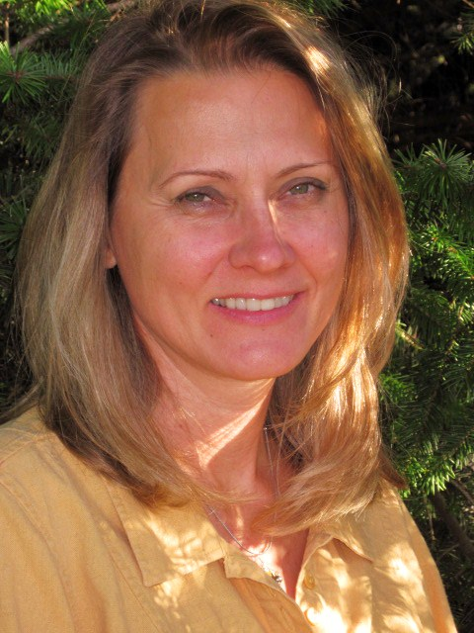 | Carma Erickson-Hurt, RN, MSN, APRN, ACHPN is a Clinical Nurse Specialist specializing in palliative care. Carma retired from the United States Navy in 2007 and currently serves as faculty at Grand Canyon University. She also consults for South Coast Hospice and Palliative care in Coos Bay, Oregon. Carma lectures and trains staff in the care of patients near the end of life through bedside teaching and formal programs such as the End of Life Nursing Education Consortium course throughout the U.S and internationally. She has traveled to Africa providing palliative care education as part of the Department of Defense component of the President’s Emergency Plan for AIDS Relief (PEPFAR). Most recently Carma volunteered with Project HOPE as the Chief Nursing Officer for disaster relief medical care aboard the USNS Comfort hospital ship in response to the earthquake in Haiti. She is a consultant for Project HOPE in the development of the Nelson Mandela Children’s Hospital project in South Africa. She volunteers on the educational products committee for the Hospice and Palliative Nurse’s Association (HPNA).  Carma Erickson-Hurt, APRN, BC-PCM  Clinical Nurse Specialist  Coos Bay, OR 97420  Phone: +1-541-269-2986 (Direct line/Voice mail)  Fax: +1-541-269-4987  Email: ecarma@hotmail.com

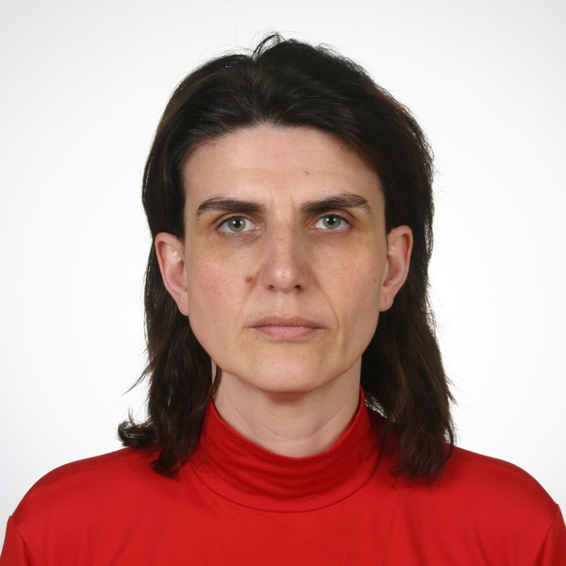 | Nicoleta Mitrea, RN is the Director of Nursing for Hospice Casa Sperantei in Brasov, Romania. Mrs. Mitrea’s area of specialty is palliative care and is an ELNEC (End-of-Life Nursing Education Consortium) trainer. She also received training in palliative care from the Harvard Medical School Palliative Care Education and Practice course in the United States. Mrs. Mitrea’s has expertise and knowledge in curriculum development with organizing, supervising and teaching palliative care courses in Romania and other Eastern European countries. She serves as the program director of several grants: East-East-Partnership Beyond Borders Program funded by the Open Society Institute, US and Advanced Training for Nurses in Palliative Care funded by Bristol Myers Squibb Foundation through City of Hope, United States..  Nicoleta Mitrea, RN  Director of Nursing  National Coordinator of Palliative Nursing Education  Hospice “Casa Sperantei”, Brasov  Sitei 17A, 500074, Brasov, Romania  Phone: 0040 734 889 509  Fax: 0040 474 467  E-mail: nicoleta.mitrea@hospice.ro

